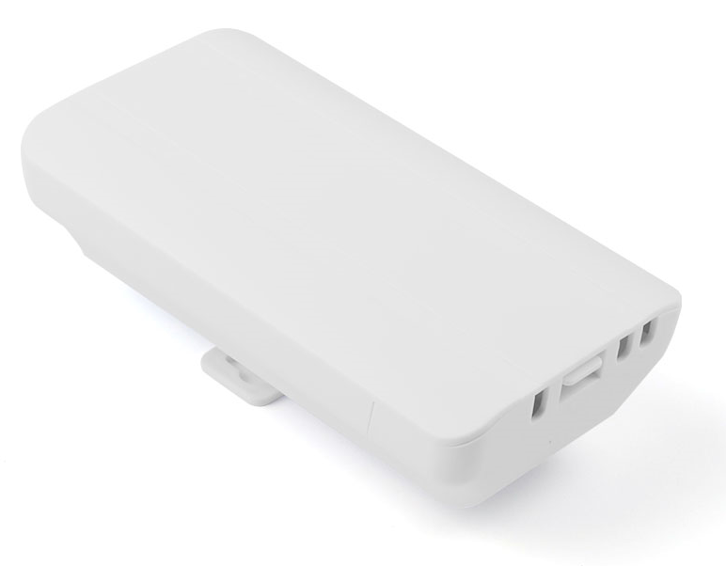
Product Features
- Digital one-click pairing with automatic connection and no setup required—simple, fast, and completed without a phone or computer.
- Supports peer-to-peer and point-to-multipoint bridging, offering flexible applications to meet diverse use cases.
- Specifically designed for elevator monitoring, it operates on the 2.4 GHz frequency band with a maximum wireless transmission rate of 300 Mbps, ensuring smooth HD video transmission and stable, reliable performance.
- Equipped with an MTK engineering-grade chip, delivering stable and reliable performance.
- With a sleek and compact design, it's easy to install—available for wall mounting or bracket mounting.
- Supports automatic restart, reduces system operation cache, optimizes system performance, and ensures smooth long-term device operation.
- Supports hiding the bridging SSID from wireless signals to prevent wireless devices from detecting it, protect network data from malicious attacks, and ensure user data security.
- Supports both 12–24 V PoE and 12 V DC power supplies, featuring plug-and-play functionality for flexible power sourcing and reduced installation costs.
- Featuring an outdoor rain-resistant design with IP65 protection rating, it is resistant to rain, dust, wind, and sunlight, effortlessly adapting to various harsh outdoor conditions while ensuring long-term stable operation.
- Suitable for various outdoor applications, including elevator monitoring, construction site surveillance, tower crane monitoring, scenic area monitoring, factory premises monitoring, port monitoring, residential community monitoring, and other scenarios.

size of product
product name | 2.4G 300M Elevator Digital Wireless Bridge
product model | WB2430D
Hardware Specifications
hardware system | Main Chip | MT7628DAN
hardware system | internal storage | Built-in 64 MB
hardware system | FLASH | 8MB
Wireless Parameters | protocol standard | IEEE 802.11b/g/n
Wireless Parameters | Working Frequency Band | 2.4GHz：2412MHz ~2472MHz
Wireless Parameters | Wireless Speed | 300Mbps
Wireless Parameters | transmitting power | 18dBm
physical interface | network interface | Two 10/100 Mbps Ethernet ports (supporting 12–24 V PoE power supply)
physical interface | Hardware Button | 1 digital button/RESET button
physical interface | Power Supply Interface | One DC power port, supporting 12V DC power supply
physical interface | Pull the switch | 1 pull-down switch (free switching between terminals A and B)
Wireless Type | Wireless Type | Built-in 5dBi bipolar directional antenna
pilot lamp | LED pilot lamp | In order: POWER, LAN, LAN, WIFI, 4*LINK
Power Supply/Power Consumption | power supply mode | Supports DC 12V/1A power supply and 12–24V PoE power supply
Power Supply/Power Consumption | Total Power of the Device | ﹤5W
Product Accessories | main engine | 2.4G 300M Elevator Digital Wireless Bridge Host *1
Product Accessories | Power Adapter | 12V 0.5A PoE power supply
Product Accessories | else | Stainless steel clamp *1  User Manual *1  Qualification Certificate *1
Appearance/Packaging/Weight | Appearance Color | white
Appearance/Packaging/Weight | product size | 173mm*90mm*58m
Appearance/Packaging/Weight | packing measurement | 290 mm × 201 mm × 66 mm (set of two)
Appearance/Packaging/Weight | weight | 0.62kg
Appearance/Packaging/Weight | carton size | 590mm*346mm*422m
Appearance/Packaging/Weight | packing quantity | 40 pieces per box
Appearance/Packaging/Weight | net weight | 12.4kg
Appearance/Packaging/Weight | rough weight | 14kg
else | The optimal power supply distance for a PoE network cable | Within 65 meters (using Category 5e or higher network cables)
else | Bridge Distance | 0–0.5 km
else | IPC Load Capacity | Route 5: No lag, no delay
else | way to install | Rod mounting, Wall-mounted installation, Support bracket installation
else | levels of protection | IP65 rating; 2 kV lightning protection
Software Specifications
system model | Primary Mode (AP End), Secondary Mode (Client), WDS Mode
Bridge Management | Button switching mode: Switches between digital one-touch pairing and manual pairing
Bridge Networking Method | Digital One-Touch Pairing | Supports one-touch pairing for convenience, simplicity, and speed
Bridge Networking Method | Manual Pairing | support
Bridge Networking Method | WDS pair | support
Bridge Networking Method | Point-to-point bridging | support
Bridge Networking Method | Point-to-multipoint bridging | support
network settings | LAN Configuration | support
network settings | DHCP set up | support
system mode | Local Area Network Information Display | support
system mode | Wireless Information Display | support
system mode | Wireless Network Status Display | support
Wireless Settings | SSID revise | support
Wireless Settings | Wireless Mode | Supports 11B,11G, and 11B/G/N
Wireless Settings | SSID hide | support
Wireless Settings | Wireless Channel | Support Channels 1–13
Wireless Settings | transmitting power | adjustable
Wireless Settings | Bandwidth Settings | support
Wireless Settings | Wireless Encryption | support
Wireless Settings | way of encryption | WPA-PSK，WPA2-PSK，WPA/WPA2-PSK
Wireless Settings | Encryption Type | AES、TKIP、AES/ TKIP
Wireless Settings | Wireless User Isolation | support
WDS manage | WDS manage | support
System Settings | Web interface management | support
System Settings | SL | Supports Chinese/English
System Settings | Administrator Settings | support
System Settings | System restart | support
System Settings | factory data reset | support
System Settings | Download Configuration File | support
System Settings | Import Configuration File | support
System Settings | firmware upgrade | support
System Settings | Reset定时 restart | support
System Settings | NTP set up | support

interface specification
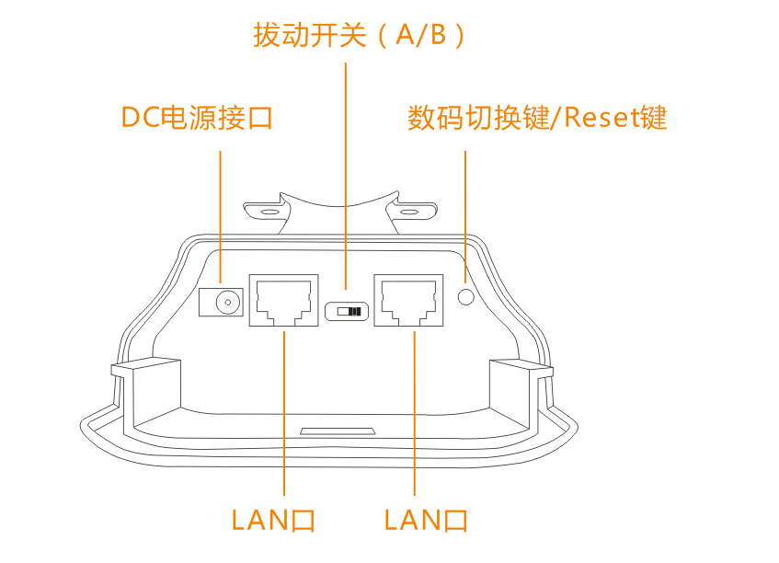
product size
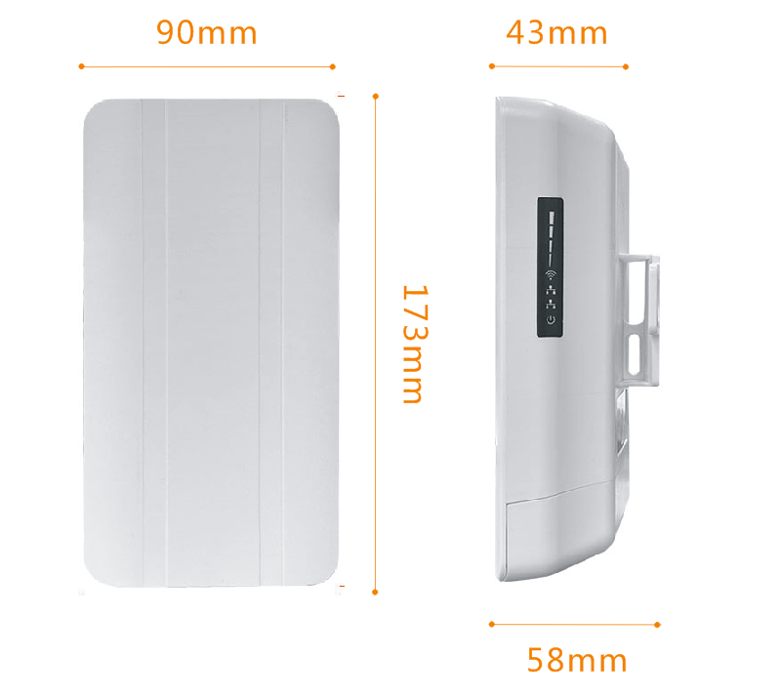
Product Application
I. Point-to-point wireless monitoring transmission applications 1

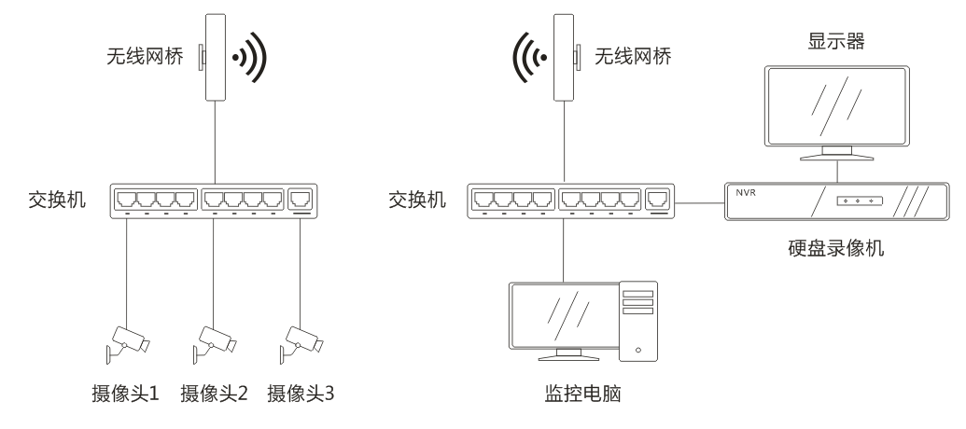

II. Point-to-point wireless monitoring transmission applications 2

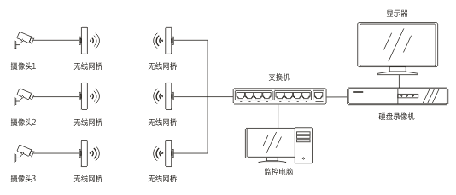

III. Wireless Monitoring Transmission: Point-to-Multipoint Applications 3

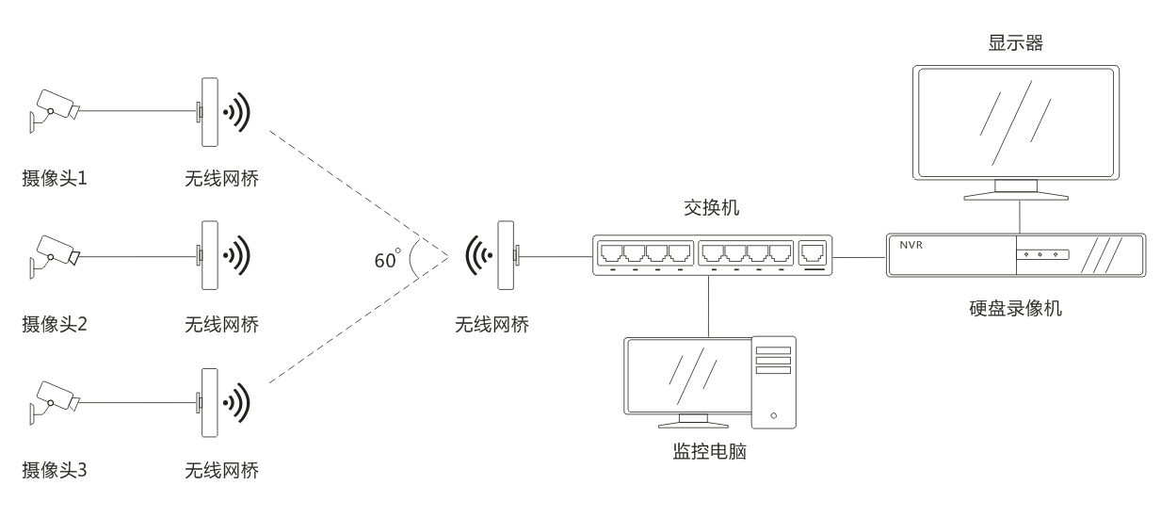

IV. Internet of Things Data Transmission Applications

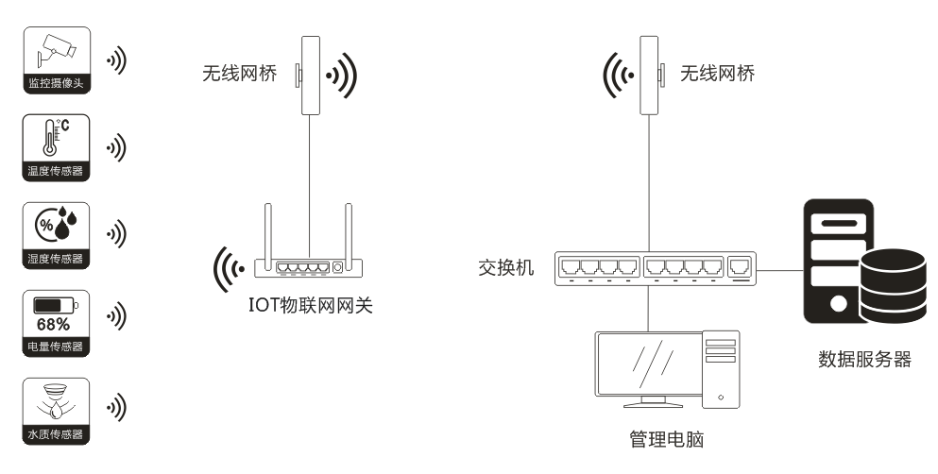

V. Applications of Wireless Data Transmission over the Internet 1

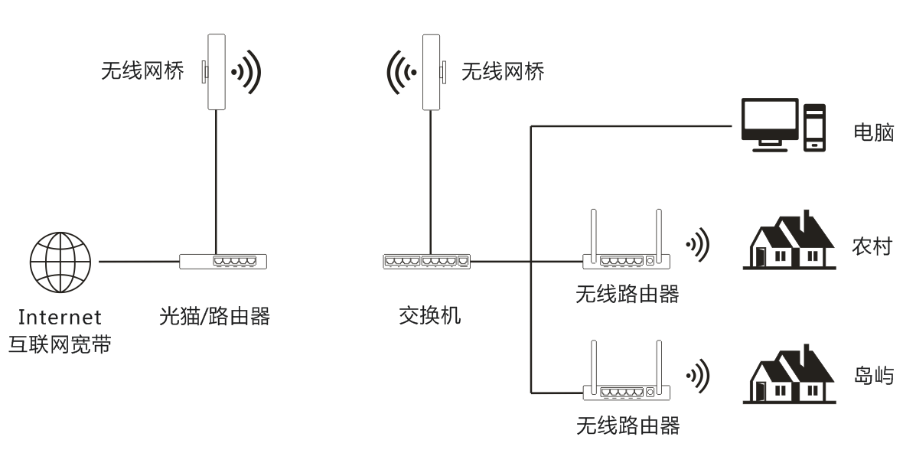

VI. Internet Wireless Transmission Applications 2
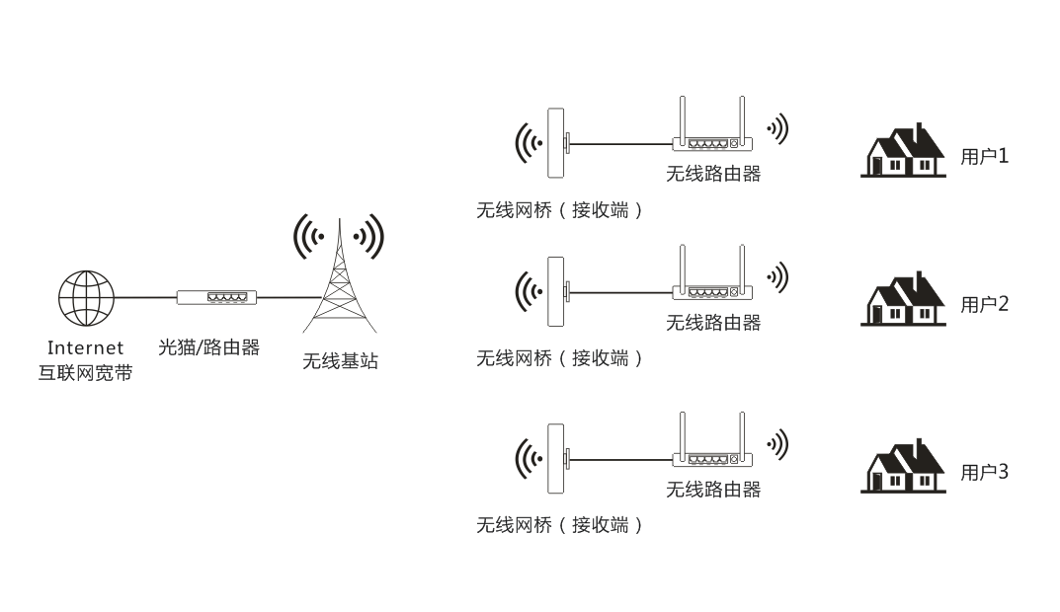

VII. Internet Coverage Applications 3

